
Business Question and Visualization Report

Date | 18 August 2026
Team ID | xxxxxx
Project Name | India’s agricultural crop production analysis (1997-2021)
Maximum Marks | 5 Marks

Business Questions and Visualisations.
Q.1 How has agricultural yield changed over the years from 1997 to 2021?
Visualizations : line chart showing the year-wise trend or total agricultural yield.
The chart helps identify years of increasing /decreasing agricultural yield and the overall production trend over the period.
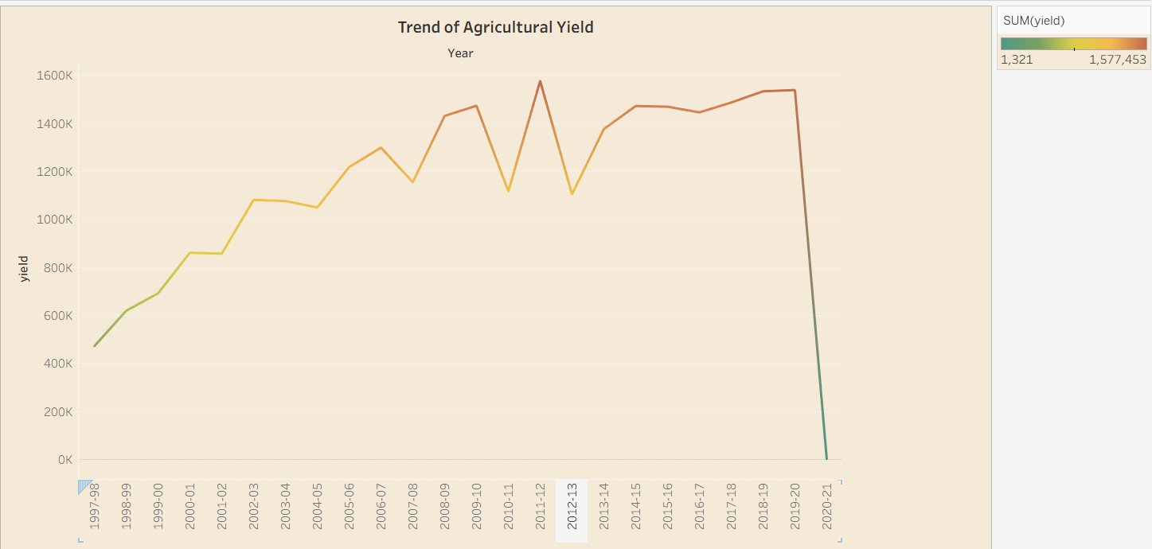

Q.2 How is agricultural production distributed across different states of India?”
Visualization: Map showing state- wise total agricultural production in India.

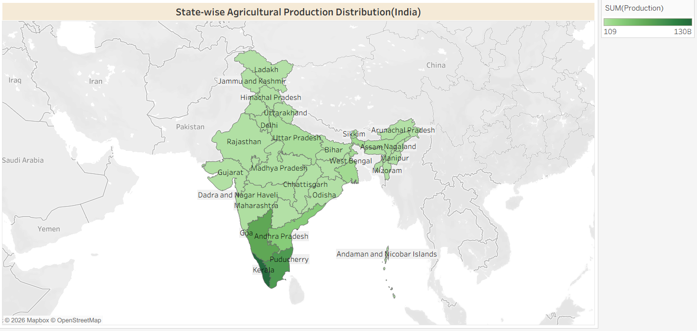
Q.3 Which crops occupy the largest cultivated area in India, and how does the cultivated area vary among different crops?
Visualization- Horizontal bar chart comparing the cultivated area of different crops.
Insight- Rice has the largest cultivated area, followed by wheat, while sugarcane, coconuts, and potato occupy comparatively smaller cultivated areas.
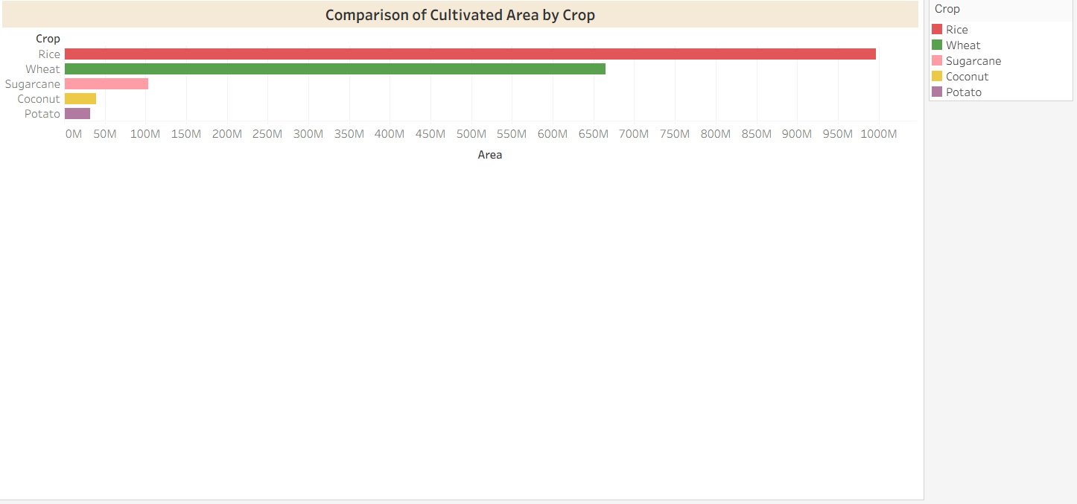

Q.4 Which states have the largest cultivated area in India?
Visualization: Bar chart comparing the cultivated area across different states.

Screenshot of visualization –
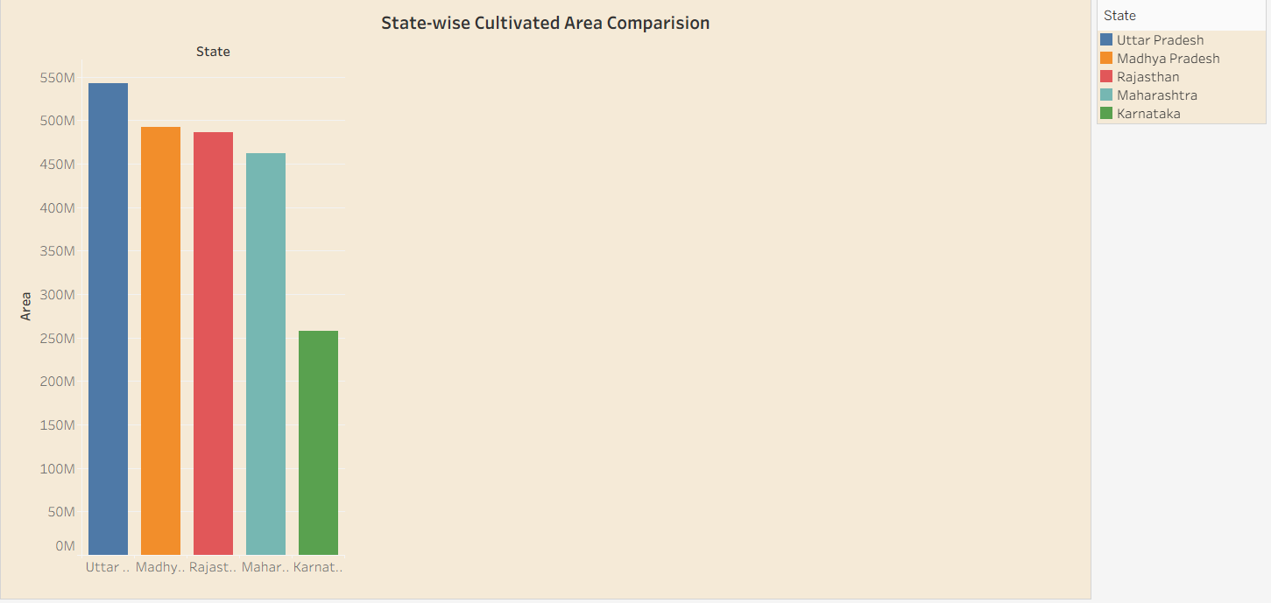

Q.5 Which states are the leading contributors to agricultural production in India?
Visualization: Bar chart comparing total agricultural production across selected states.
Screenshot of visualization-
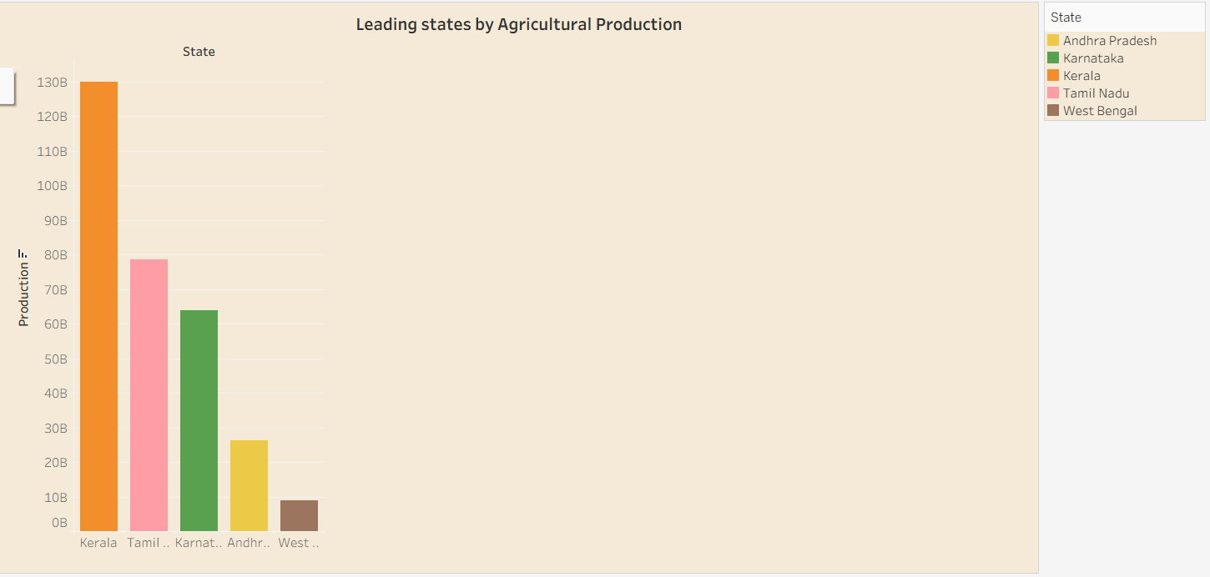
Q.6 How has total agricultural production changed over the years from 1997 to 2021?
Visualization - Bar chart showing year -wise total agricultural production.
Screenshot of visualization-
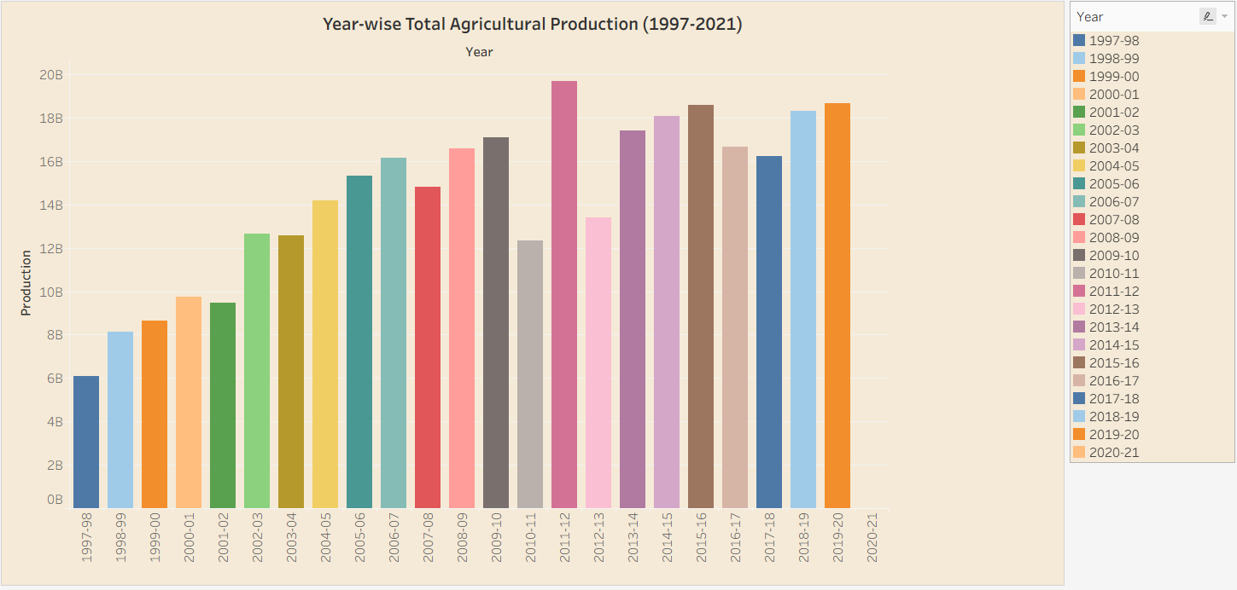

Q.7 How is agricultural production distributed across different production unit types?
Visualization- Donut chart showing the distribution of total agricultural production by unit type.
Screenshot of visualization-
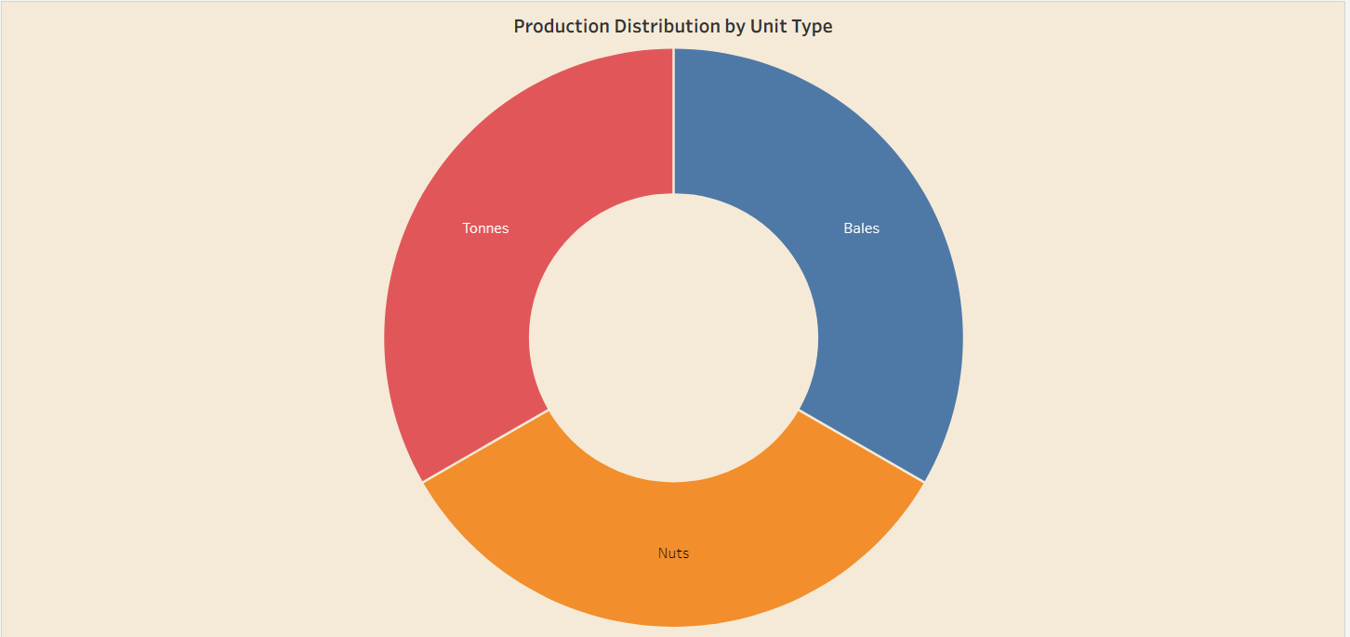

Q.8 Which agricultural seasons contribute the most to India’s total agricultural production?’
Visualization- Pie chart showing the share of total agricultural production by season.
Screenshot of visualization-
